INTERACTIVE PKU BULLETIN BOARD
“NewsNow”

EMIR HARRIS BIN M ZAINUDIN
Diploma in Computer Science
UNIVERSITI MALAYSIA PAHANG
AL-SULTAN ABDULLAH
UNIVERSITI MALAYSIA PAHANG AL-SULTAN ABDULLAH
DECLARATION OF THESIS AND COPYRIGHT

Author’s Full Name | : | EMIR HARRIS BIN M ZAINUDIN
Date of Birth | : | 6 NOVEMBER 2006
Title | : | INTERACTIVE PKU BULLETIN BOARD
Academic Session | : | 2025/2026

I declare that this thesis is classified as:

☐ | CONFIDENTIAL | (Contains confidential information under the Official Secret Act 1997)*
☐ | RESTRICTED | (Contains restricted information as specified by the organization where research was done)*
☐ | OPEN ACCESS | I agree that my thesis to be published as online open access (Full Text)

I acknowledge that Universiti Malaysia Pahang Al-Sultan Abdullah reserves the following
rights:

1. The Thesis is the Property of Universiti Malaysia Pahang Al-Sultan Abdullah
2. The Library of Universiti Malaysia Pahang Al-Sultan Abdullah has the right to make copies of the thesis for the purpose of research only.
3. The Library has the right to make copies of the thesis for academic exchange.

Certified by:

_________  (Student’s Signature)  ____061106101459____  New IC/Passport Number  Date: | _______________________  (Supervisor’s Signature)  _NORAZIAH BINTI AHMAD_  Name of Supervisor  Date:

NOTE : * If the thesis is CONFIDENTIAL or RESTRICTED, please attach a thesis declaration letter.


SUPERVISOR’s DECLARATION
I/We* hereby declare that I/We* have checked this thesis/project* and in my/our* opinion, this thesis/project* is adequate in terms of scope and quality for the award of the degree of *Doctor of Philosophy/ Master of Science.

_______________________________
(Supervisor’s Signature)
Full Name : NORAZIAH BINTI AHMAD
Position :
Date :

_______________________________
(Co-supervisor’s Signature)
Full Name :
Position :
Date :

STUDENT’S DECLARATION
I hereby declare that the work in this thesis is based on my original work except for quotations and citations which have been duly acknowledged. I also declare that it has not been previously or concurrently submitted for any other degree at Universiti Malaysia Pahang Al-Sultan Abdullah or any other institutions.


_______________________________
(Student’s Signature)
Full Name : EMIR HARRIS BIN M ZAINUDIN
ID Number : RC24201
Date : 1 October 2025

INTERACTIVE PKU BULLETIN BOARD
“NewsNow”

EMIR HARRIS BIN M ZAINUDIN
Thesis submitted in fulfillment of the requirements
for the award of the degree of
Diploma in Computer Science
Faculty of Computing
UNIVERSITI MALAYSIA PAHANG AL-SULTAN ABDULLAH
OCTOBER 2025

ACKNOWLEDGEMENTS
The Interactive PKU Bulletin Board, “News Now” project was designed and implemented to provide a visually appealing, accessible, and informative communication platform for the university community. The layout, colour scheme, and content highlights were carefully structured to ensure maximum readability, immediate engagement, and intuitive navigation of critical health information.
Key design components, such as thematic sections, clear headings, infographic panels, and strategically placed calls to action, were developed to facilitate the general theme of promoting proactive health and well-being. These components align with the centre's clean, trustworthy, and supportive identity. The project relied heavily on principles of effective visual communication and health literacy to ensure the messages—covering topics such as mental health resources, immunization schedule, and general wellness tips—are understandable and actionable for all students and staff.
Custom-designed visuals and organized content structure were utilized to maintain clarity and consistency throughout the board's entire display area. Throughout the conceptual and design process, various layout alternatives and material presentations were explored to optimize the display's impact and coordinate the intended educational character. The bulletin board successfully integrates dynamic content slots to ensure up-to-date announcements and real-time event promotions, thereby enhancing its relevance and functional utility.

ABSTRAK
Projek ini melibatkan pembangunan sebuah platform papan kenyataan dalam talian untuk Pusat Kesihatan Universiti (PKU) yang bertujuan memudahkan penyebaran maklumat kesihatan umum dan perkhidmatan klinik secara lebih sistematik dan berpusat. Dalam era digital masa kini, pelajar universiti sering berdepan dengan kesukaran untuk mendapatkan maklumat kesihatan yang tepat, terkini, dan boleh dipercayai disebabkan oleh penyebaran maklumat yang tidak tersusun serta bergantung kepada pelbagai saluran yang berbeza. Keadaan ini boleh menjejaskan tahap kesedaran kesihatan dalam kalangan pelajar serta mengurangkan keberkesanan penyampaian maklumat oleh pihak PKU.
Sehubungan itu, pembangunan laman web ini bertujuan untuk merapatkan jurang komunikasi antara pihak PKU dan pelajar dengan menyediakan satu platform yang pintar, interaktif, dan mesra pengguna. Sistem ini direka untuk membolehkan pelajar mengakses pengumuman kesihatan, jadual acara, kempen kesedaran, serta maklumat berkaitan waktu operasi klinik dengan lebih mudah dan pantas. Selain itu, platform ini juga memberi penekanan terhadap pengalaman pengguna (user experience) yang lebih baik melalui susun atur yang teratur, navigasi yang jelas, dan kandungan yang relevan dengan keperluan pengguna.
Dari sudut teknikal, kerangka kerja sistem ini dibangunkan menggunakan teknologi pembangunan web seperti HTML, CSS, dan JavaScript bagi memastikan kebolehaksesan yang tinggi serta keserasian merentas pelbagai peranti. Tambahan pula, sistem ini menyediakan fungsi pentadbiran yang membolehkan kakitangan PKU mengurus, mengemaskini, dan menerbitkan siaran dengan lebih cekap. Pada masa yang sama, pengguna akhir iaitu pelajar dapat menerima maklumat kesihatan dan pengumuman yang disesuaikan mengikut keperluan mereka.
Secara keseluruhannya, pembangunan platform ini dijangka dapat meningkatkan keberkesanan penyampaian maklumat kesihatan, menggalakkan kesedaran dalam kalangan pelajar, serta menyokong usaha PKU dalam menyediakan perkhidmatan kesihatan yang lebih efisien dan responsif kepada komuniti universiti.

ABSTRACT
This project involves the development of an online bulletin board platform for the University Health Centre (PKU) aimed at facilitating the dissemination of general health information and clinic-related services in a more systematic and centralized manner. In today’s digital era, university students often face challenges in accessing accurate, up-to-date, and reliable health information due to the fragmented nature of information across multiple channels. This situation can negatively impact health awareness among students and reduce the effectiveness of information delivery by the PKU.
Therefore, the development of this website aims to bridge the communication gap between the PKU and students by providing a smart, interactive, and user-friendly platform. The system is designed to enable students to easily and quickly access health announcements, event schedules, awareness campaigns, and information regarding clinic operating hours. In addition, the platform emphasizes an improved user experience through a well-structured layout, clear navigation, and content tailored to users’ needs.
From a technical perspective, the system framework is developed using web technologies such as HTML, CSS, and JavaScript to ensure high accessibility and cross-device compatibility. Furthermore, the system provides administrative functionalities that allow PKU staff to efficiently manage, update, and publish announcements. At the same time, end users, namely students, are able to receive health information and announcements that are tailored to their needs.
Overall, the development of this platform is expected to enhance the effectiveness of health information dissemination, promote health awareness among students, and support the PKU in delivering more efficient and responsive healthcare services to the university community.

TABLE OF CONTENT
DECLARATION
TITLE PAGE
ACKNOWLEDGEMENTS ii
ABSTRAK iii
ABSTRACT iv
TABLE OF CONTENT v
LIST OF TABLES viii
LIST OF FIGURES ix
LIST OF ABBREVIATIONS x
LIST OF APPENDICES xi
CHAPTER 1 INTRODUCTION 12
1.1 Background of Study 12
1.2 Problem Statement 13
1.3 Objective 13
1.4 Project Scope 13
1.5 Thesis Organization 14
CHAPTER 2 LITERATURE REVIEW 15
2.1 Introduction 15
2.2 Three Existing Systems 15
2.3 Requirement Elicitation 16
2.4 Comparison Among Existing Systems 16
2.5 Summary 17
CHAPTER 3 METHODOLOGY 18
3.1 Introduction 18
3.2 Software Process 19
3.2.1 Software Development Life Cycle (SDLC) 19
3.2.2 Gantt Chart 21
3.3 Project Requirement 21
3.3.1 Functional Requirement 21
3.3.2 Non-Functional Requirement 21
3.3.3 General Flow Chart 22
3.3.4 General Use Case Diagram 23
3.3.5 Context Diagram (DFD Level 0) 24
3.3.6 DFD Level 1 25
3.4 Proposed Design 26
3.4.1 Class Diagram 26
3.5 Data Design 27
3.5.1 ERD 27
3.6 Proof of Concepts 28
3.7 Testing Plan 33
CHAPTER 4 RESULTS AND DISCUSSION 35
4.1 Introduction 35
4.2 Table 35
CHAPTER 5 CONCLUSION 37
5.1 Introduction 37
REFERENCE 38
APPENDICES 40

LIST OF TABLES
Table 1.1 RAD Advantages 20

LIST OF FIGURES
Figure 1.1 RAD 19
Figure 1.2 Gantt Chart 21
Figure 1.3 Flowchart 23
Figure 1.4 Use Case Diagram 24
Figure 1.5 Context Diagram 25
Figure 1.6 DFD Level 1 26
Figure 1.7 Class Diagram 27
Figure 1.8 Entity Relationship Diagram 28

LIST OF ABBREVIATIONS
PKU | Pusat Kesihatan Umum
RAD | Rapid Application Development

LIST OF APPENDICES
No table of figures entries found.

INTRODUCTION

Background of Study
In today’s educational environment, effective communication of health-related information is crucial to supporting the well-being of university students and staff. At Universiti Malaysia Pahang Al-Sultan Abdullah (UMPSA), health announcements, clinic schedules, and wellness resources are primarily disseminated through traditional methods such as physical bulletin boards, static PDF documents, and irregular social media updates. While these methods have been historically functional, they are increasingly inadequate in meeting the needs of a tech-savvy, mobile-oriented academic community. The absence of a centralized, dynamic, and interactive digital platform leads to fragmented information flow, reduced accessibility, and missed critical updates—such as vaccination drives, mental health campaigns, or changes in clinic operating hours.
This project is motivated by the growing necessity to modernize health communication within university settings, aligning with global trends toward digital transformation in public health dissemination. The research aims to design and implement a dedicated online bulletin board system—termed “NewsNow”—that serves as a unified, real-time communication channel between the Pusat Kesihatan Umum (PKU) and the university community. By leveraging contemporary web technologies, the system seeks to enhance health literacy, promote proactive wellness behaviours, and streamline administrative workflows, thereby fostering a more informed and healthier campus environment.

Problem Statement
Effective communication between healthcare providers and the public is essential to ensure that important announcements, health campaigns, operational updates, and public health information are delivered promptly and efficiently. Currently, the PKU (Pusat Kesihatan Umum) spread announcements and bulletin information through various unofficial and platforms such as Instagram, Facebook, and sections of its official website.
However, relying on social media platforms presents several challenges. Important announcements can easily be missed due to social media algorithms, information overload, or users not actively following PKU's accounts. Furthermore, the information is scattered across multiple channels, making it difficult for users to locate and access relevant updates consistently.
Although PKU maintains an official website, bulletin and announcement information is often embedded within pages that are not prominently displayed or easily accessible to the public. As a result, users may experience difficulties finding important information, leading to reduced awareness of healthcare services, events, operational changes, and public health notices.
The absence of a centralized and dedicated bulletin board system limits the effectiveness of information dissemination and may negatively impact communication between PKU and the UMPSA community. Therefore, there is a need to develop a web-based PKU Bulletin Board System that consolidates announcements and notices into a single, accessible platform. Such a system would improve information visibility, enhance public accessibility, and ensure that important updates are communicated more effectively to all users.

Objective

To investigate and document the specific needs of PKU staff and UMP students regarding centralized health announcement features and content.

To design and develop a user-friendly, cross-platform web application for a PKU Health Bulletin Board that allows authenticated PKU staff to publish and manage announcements efficiently.

To evaluate the NewsNow Web App to ensure it is effective in delivering timely information and enhancing user accessibility.

Project Scope

User Types: PKU Staff/Admin (to manage posts) and Students/Clients (to view and search posts).

Client Functionality: Users can view announcements, filter/search for specific health topics (e.g., mental health, clinic hours)

Staff/Admin Functionality: Staff and Administrators can create, edit, publish, and delete new bulletin posts and manage content categories.

System Development: The system will be developed as a responsive web application and should be compatible with modern web browsers on both desktop and mobile devices.

Thesis Organization
This thesis is organized into five chapters:
Chapter 1: Introduction - Presents the background, problem statement, objectives, scope, and organization of this research on the Interactive PKU Bulletin Board system.
Chapter 2: Literature Review - Examines existing health communication systems at UMPSA, analyses requirements, and compares approaches to establish the research foundation.
Chapter 3: Methodology - Details the development process, requirements, design, and testing framework for implementing the system.
Chapter 4: Results and Discussion - Presents the developed system, evaluates its performance, and discusses findings against the research objectives.
Chapter 5: Conclusion - Summarizes research achievements, limitations, and provides recommendations for future improvements.
References and Appendices provide supporting academic sources and supplementary materials.

LITERATURE REVIEW

Introduction
The literature review explores the theoretical and practical foundations necessary for developing the NewsNow Bulletin Board. This section examines existing methods of health information dissemination, the shift toward digital platforms in university environments, and the specific web technologies utilized to create a responsive and efficient system

Three Existing Systems
Traditional information dissemination at Universiti Malaysia Pahang Al-Sultan Abdullah (UMPSA) primarily relies on physical bulletin boards, static websites, and decentralized social media updates. While these methods serve a purpose, they present significant challenges:

Physical Bulletin Boards: These require users to be physically present at the clinic and are often cluttered with outdated posters, making it difficult to find critical, time-sensitive information.

Web Content/PKU Official Website: Official university websites often host health information in non-interactive formats that are not mobile-friendly or easily searchable.

Social Media: While reaching a broad audience, information on social media can quickly become buried under new posts, lacking a centralized repository for long-term health resources or clinic schedules.

Requirement Elicitation
To bridge the gap between clinical administration and student needs, the system requires a framework that addresses accessibility and management efficiency.

User Experience (UX): The platform must offer a smart, user-friendly interface that allows students to make informed decisions regarding clinic services and wellness.

Administrative Control: PKU staff require an authenticated management system to publish, edit, and categorize announcements without manual labor across multiple inconsistent channels.

Responsiveness: Given the mobile-first nature of university students, the application must be cross-platform and compatible with modern web browsers on various devices.

Comparison Among Existing Systems
Digital bulletin boards offer several advantages over traditional physical or static digital methods. Key comparisons include:

Information Accessibility: Unlike physical boards, digital platforms allow for real-time updates and remote access to vaccination schedules and clinic hours.

Searchability: Digital systems provide filtering and search functions for specific health topics, such as mental health or immunization, which are impossible with physical posters.

Administrative Efficiency: Automated management through a dedicated dashboard reduces the administrative burden on PKU staff by providing a single point of truth for all official announcements.

Summary
The transition from manual, physical communication to a centralized digital framework like the Interactive PKU Bulletin Board is essential for modernizing health services at UMPSA. By leveraging technologies such as HTML, CSS, and JavaScript, the project aims to create a responsive environment that improves health literacy and ensures timely information transfer for both students and staff.

METHODOLOGY

Introduction
The methodology chapter outlines the systematic approach used to design, develop, and evaluate the “NewsNow” Interactive PKU Bulletin Board web application. This project follows a structured development lifecycle intended to bridge existing communication gaps by offering a smart, user-friendly framework for the university community. By utilizing a technology stack consisting of HTML, CSS, and JavaScript, the development process ensures the creation of a cross-platform system that is both responsive and efficient. The focus of this methodology is to provide a reliable environment where authenticated PKU staff can manage content while students gain seamless access to centralized health announcements and clinic services.

Software Process

Software Development Life Cycle (SDLC)
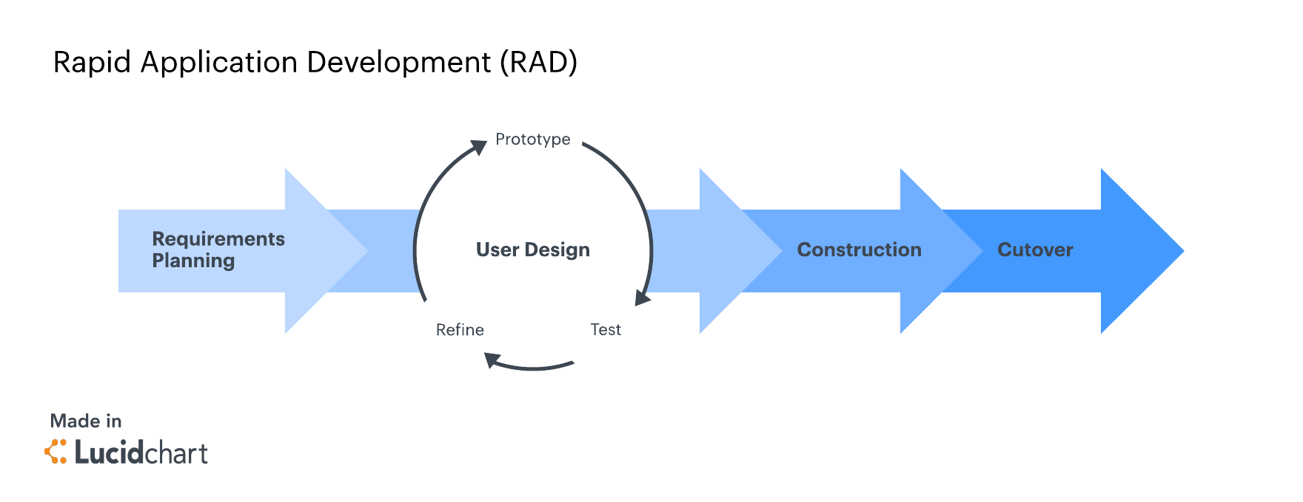
Figure 1.1 RAD

The development of the NewsNow Interactive PKU Bulletin Board follows a Rapid Application Development (RAD) methodology, an adaptive and iterative variant of the traditional Software Development Life Cycle (SDLC). RAD emphasizes accelerated delivery through modular prototyping, continuous user involvement, and flexible response to evolving requirements. The process is structured into four key phases: Requirements Planning, where initial needs are gathered from PKU staff and students; User Design, where interactive prototypes are developed and refined through repeated feedback sessions; Rapid Construction, where the system is incrementally built using a stack of HTML, CSS and JavaScript, with each module being developed, tested, and reviewed in short cycles; and Cutover, which includes final testing, deployment, and user training. This approach ensures that the system remains closely aligned with user expectations, reduces development risks, and enables timely delivery within the constraints of the academic project timeline, while still maintaining a structured pathway from conception to deployment.

Advantages | Disadvantages
- Allows for speedy development  - High adaptability and flexibility  - Active involvement of users allows for an accurate model of the prototype  - Reduced overall development costs. | - Requires user input at numerous stages  - Limited scalability for very large, tightly coupled systems

Table 1.1 RAD Advantages

Gantt Chart

Figure 1.2 Gantt Chart

Project Requirement

Functional Requirement

The system shall allow PKU staff to log in securely to a dedicated admin panel.

The system shall allow authenticated staff to create, edit, publish, and delete bulletin posts.

The system shall display bulletin to students in a structured format.

The system shall be accessible via web browsers on both desktop and mobile devices without loss of functionality.

The system shall allow students to filter bulletin posts by categories

The system shall notify PKU staff via email or dashboard alert when a new announcement is successfully published or edited.

The system shall support file uploads (e.g. images) within bulletin posts for attached resources.

The system shall provide role-based access control to ensure only authorized staff can manage content.

Non-Functional Requirement

The system shall load pages within 3 seconds under normal network conditions.

The system shall be responsive and usable on screen sizes ranging from mobile phones to desktop monitors.

The system shall maintain data consistency and prevent unauthorized access through secure authentication mechanisms.

The system shall be available at least 95% of the time during operational hours.

The system shall comply with basic accessibility standards (e.g., readable fonts, contrast ratios, keyboard navigation support).

The system shall support at least 100 concurrent users without performance degradation.

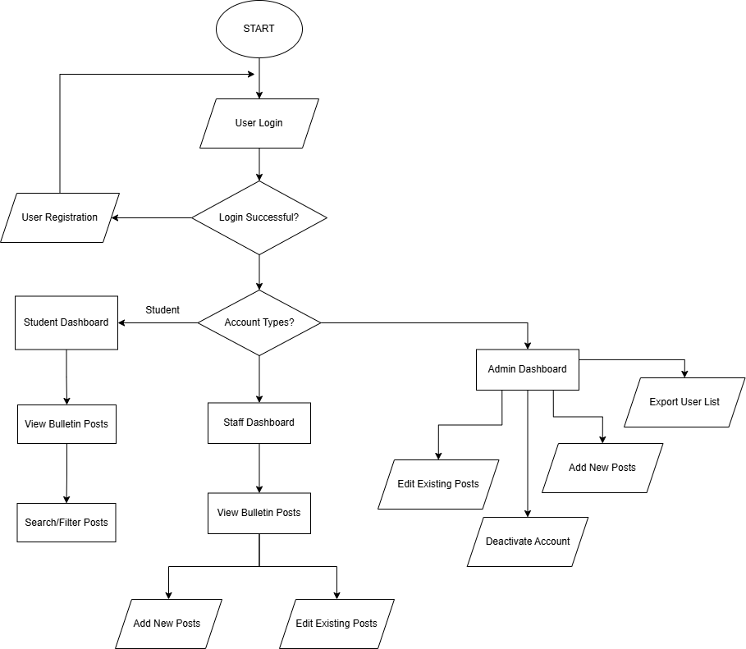
General Flow Chart

Figure 1.3 Flowchart

General Use Case Diagram
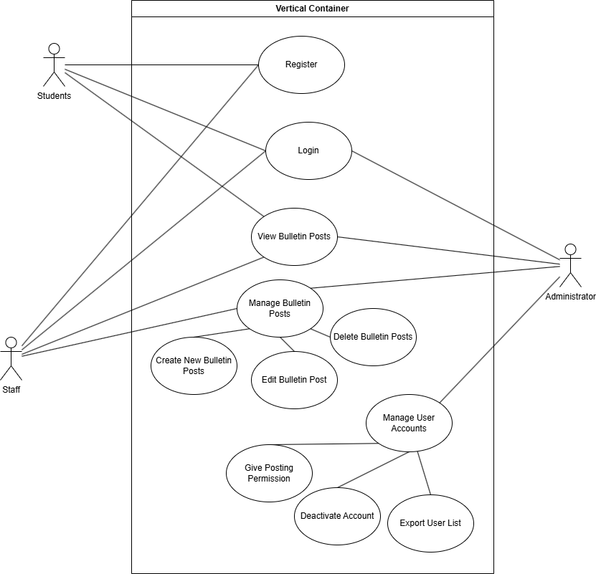
Figure 1.4 Use Case Diagram

Context Diagram (DFD Level 0)
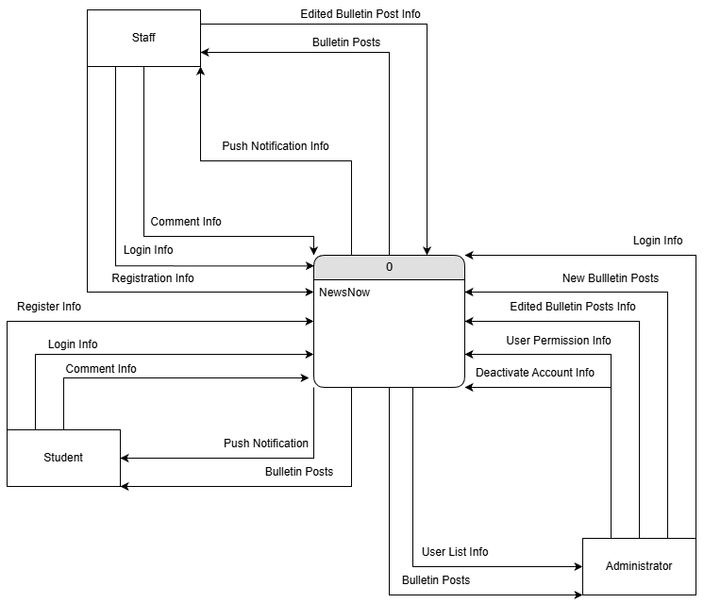

Figure 1.5 Context Diagram

DFD Level 1
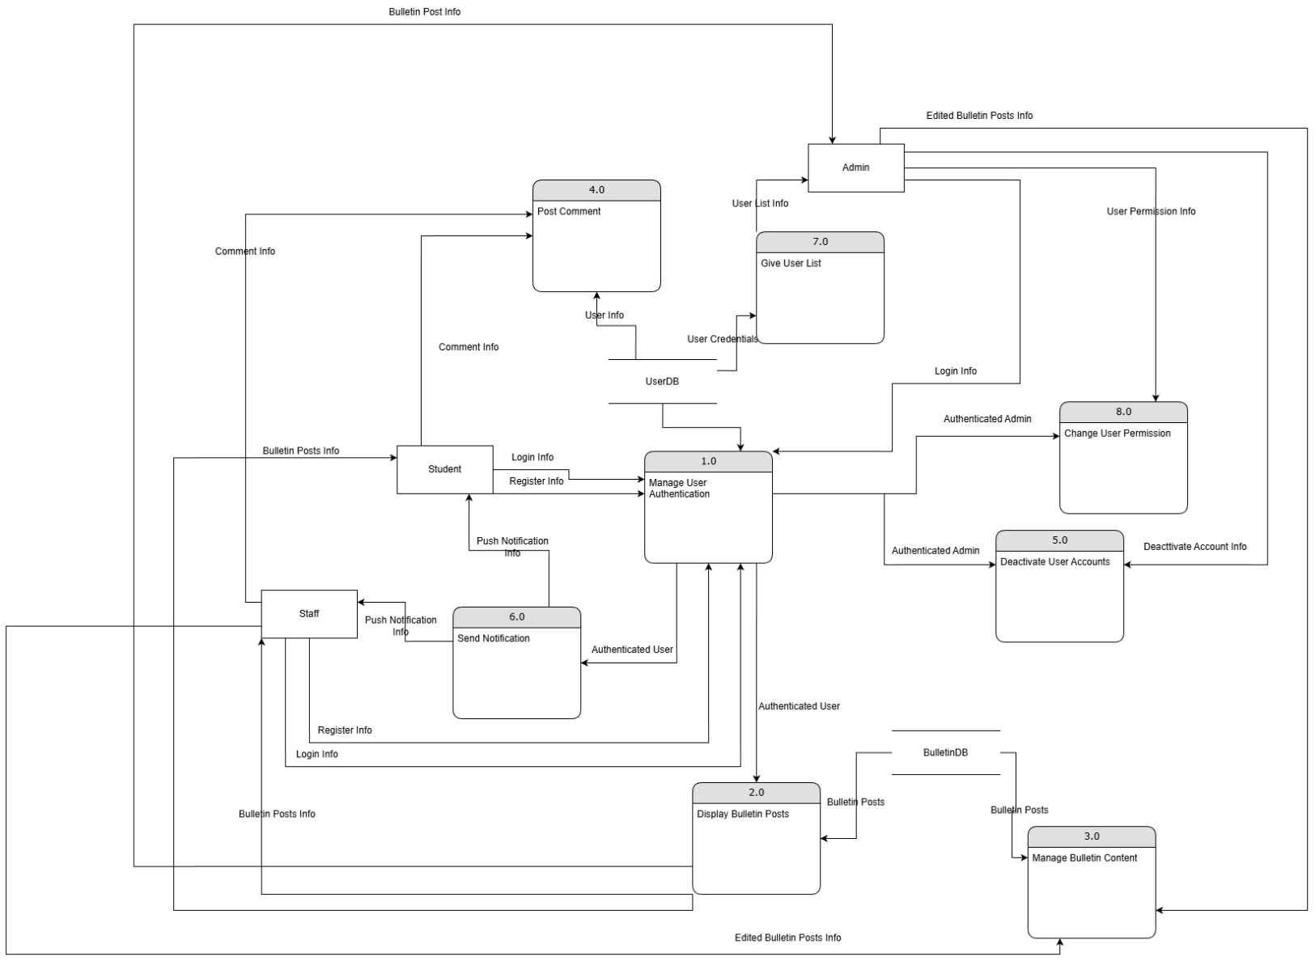

Figure 1.6 DFD Level 1

Proposed Design

Class Diagram
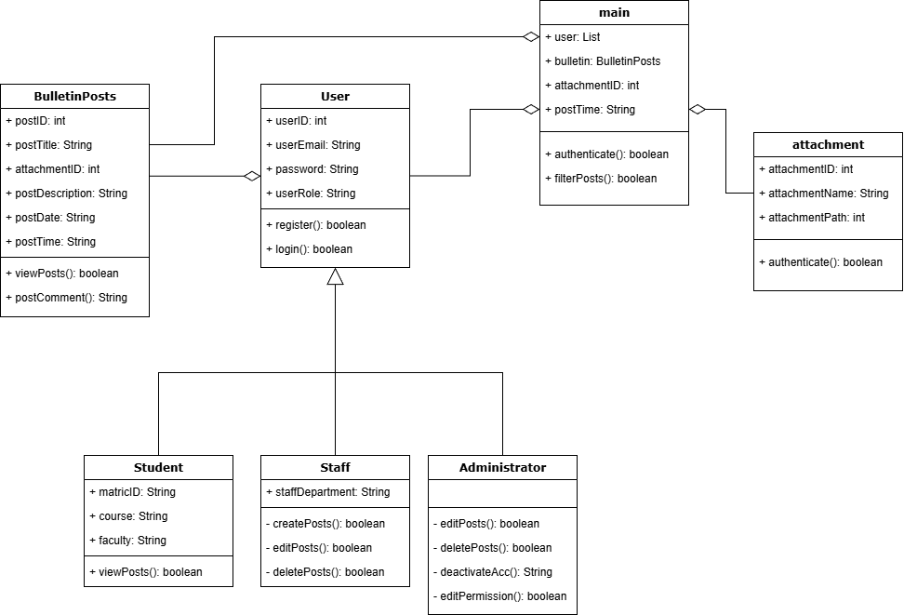
Figure 1.7 Class Diagram

Data Design

ERD
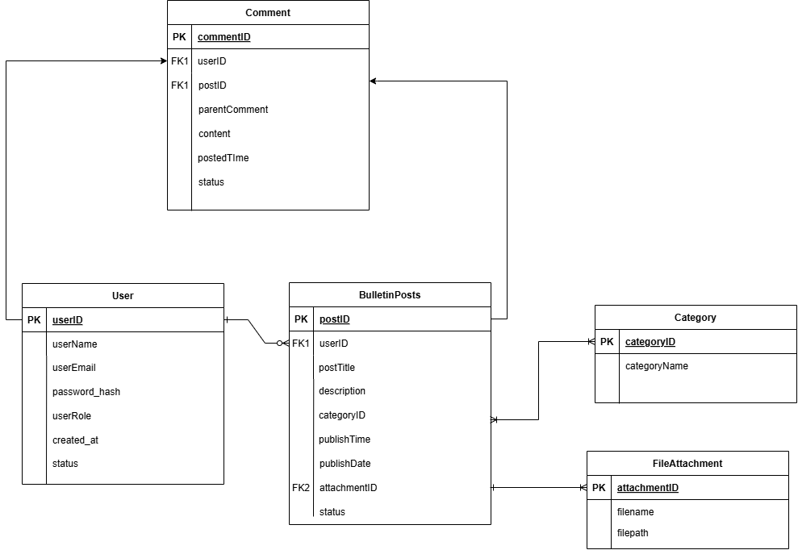
Figure 1.8 Entity Relationship Diagram

Proof of Concepts
Screen Title: | Login Page
Layout: | 01
Link From Screen: | None
Link To Screen: | Dashboard
Screen Layout: | 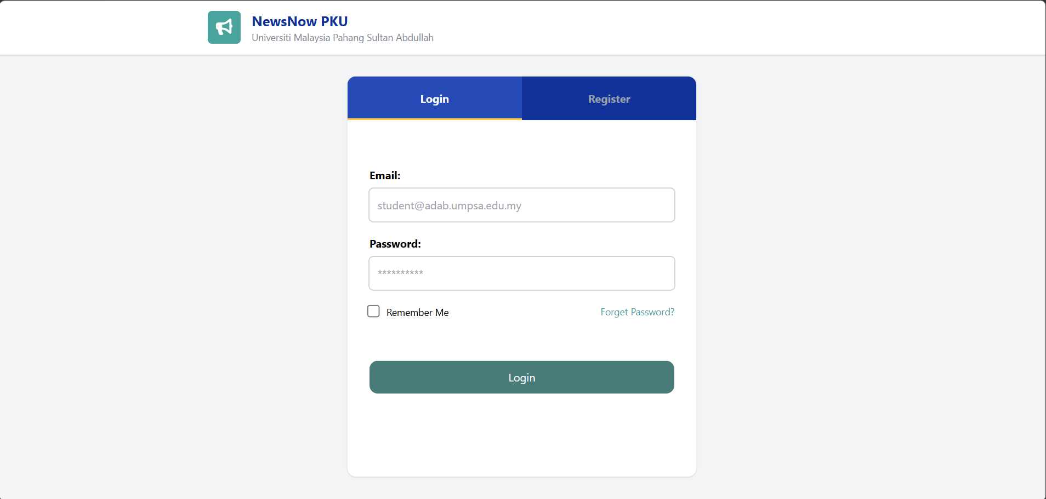
Description: | The main page after the user logs in
Multimedia Element: | Images, Button, Navigation Bar

Screen Title: | Register Page
Layout: | 01
Link From Screen: | None
Link To Screen: | Login
Screen Layout: | 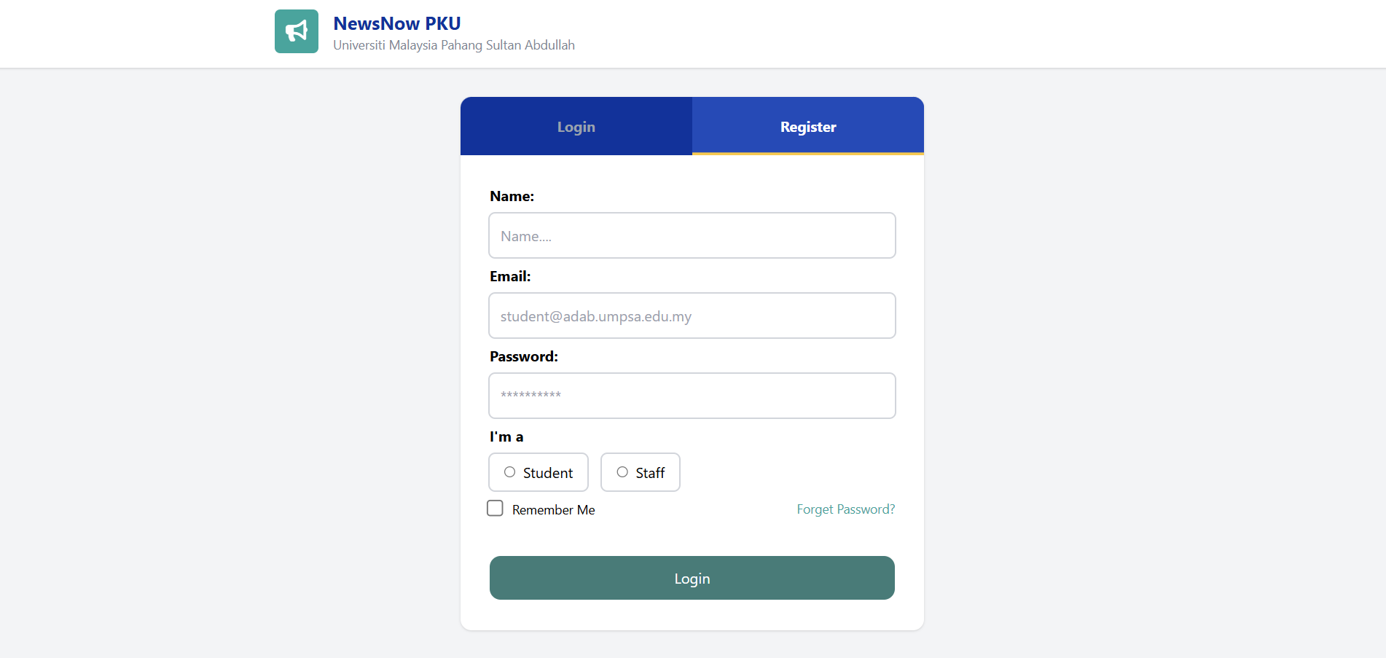
Description: | The main page after the user logs in
Multimedia Element: | Images, Button, Navigation Bar

Screen Title: | Dashboard Page
Layout: | 01
Link From Screen: | Login
Link To Screen: | Dashboard
Screen Layout: | 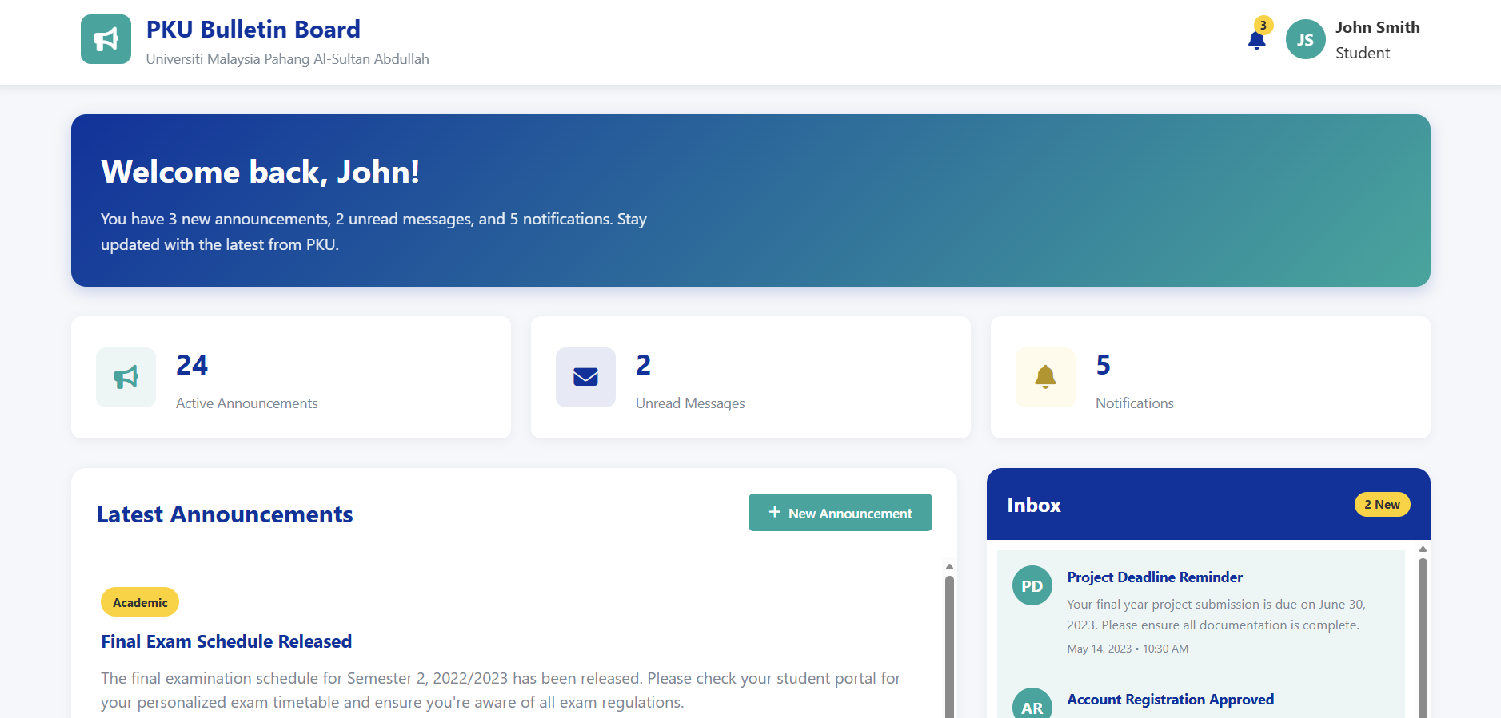
Description: | The main page after the user logs in
Multimedia Element: | Images, Button, Navigation Bar

Screen Title: | Staff Dashboard
Layout: | 03
Link From Screen: | Login Page
Link To Screen: | Staff Dashboard
Screen Layout: | 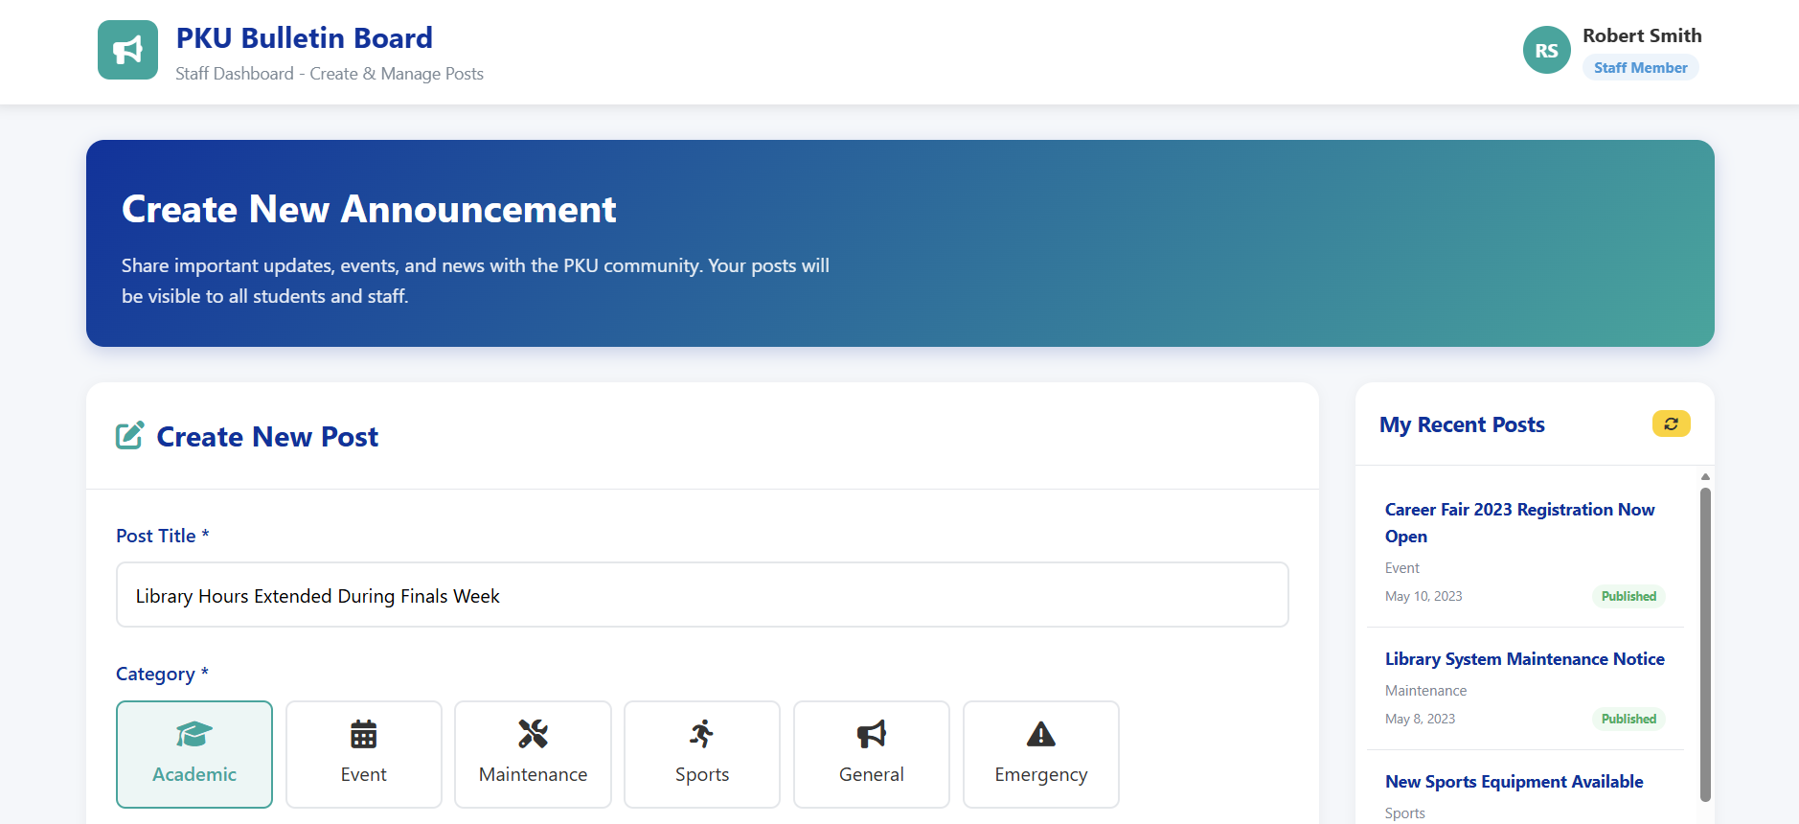
Description: | The staff home page
Multimedia Element: | Images, Button, Navigation Bar

Testing Plan

Test | Status | Feedback
General
Login | Pass/Fail
Register | Pass/Fail
Logout | Pass/Fail
Student Dashboard
View Posts | Pass/Fail
Post Comment | Pass/Fail
Staff Dashboard
Create New Post | Pass/Fail
Edit Posts | Pass/Fail
Delete Posts | Pass/Fail
View Post | Pass/Fail
Administrator Dashboard
Export User List | Pass/Fail
Deactivate Account | Pass/Fail

RESULTS AND DISCUSSION

Introduction
This chapter presents the findings derived from the implementation and testing phases of the project. It evaluates the system's performance against the initial requirements and discusses the implications of the results. The data gathered provides a comprehensive look at how the solution addresses the identified research problem, highlighting both successful outcomes and areas for future optimization.

Table
General
Feature | Expected Result | Actual Result | Status
Login | User can log in using valid credentials | Pending | Pass
Logout | User is logged out and session is cleared | Pending | Pass
Register | User can create a new account | Pending | Pass

Student Dashboard
Feature | Expected Result | Actual Result | Status
View Posts | View all active posts | Pending | Pass
Post Comment | Post Comments | Pending | Pass

Staff Dashboard
Feature | Expected Result | Actual Result | Status
Create New Posts | Create a new visible post | Pending | Pass
View Posts | View all active posts | Pending | Pass
Delete Posts | Delete posts | Pending | Pass
Edit Posts | Edit posted Posts | Pending | Pass

CONCLUSION

Introduction

REFERENCE
https://www.w3schools.com/REACT/default.asp
https://tailwindcss.com/docs/installation/using-vite
https://react.dev/learn

APPENDICES

